**Practical 2: Study and Learn List, Tuple, Set and Dictionary**

Git repository link: <https://github.com/Dhwani-S/Python-PIP.git>

Code:

#20CE140 Dhwani Suthar  
#Python Practical 2  
  
###Dictionary###  
  
#a. Write a Python script to check whether a given key already exists in a dictionary.  
d1 = {"20CE140":"Dhwani", "20CE146":"Kavya", "20CE150":"Medha"}  
print("Enter a Key:")  
keys = input()  
if keys in d1:  
 print("Key exists")  
else:  
 print("key does not exist")

o/p:

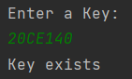  
  
  
#b. Write a Python script to merge two Python dictionaries.  
d1 = {"20CE140": "Dhwani", "20CE146": "Kavya", "20CE150": "Medha"}  
d2 = {"20CS024": "Dikshita"}  
#d1= d1+d2  
d1.update(d2)  
print(d1)

o/p:

  
  
  
#c. Write a Python program to sum all the items in a dictionary.  
price = {"Pen": 10, "Eraser": 5, "Books": 200}  
list = []  
for i in price:  
 list.append(price[i])  
total= sum(list)  
print("Total: ",total)

o/p:

  
  
#d. Write a Python script to add a key to a dictionary.  
#Sample Dictionary : {0: 10, 1: 20}  
#Expected Result : {0: 10, 1: 20, 2: 30}  
d1 = {"20CE140": "Dhwani", "20CE146": "Kavya", "20CE150": "Medha"}  
  
print("Enter a key you want to add: ")  
keys = input()  
print("Enter the corresponding value: ")  
values = input()  
d1[keys] = values  
print(d1)

o/p:

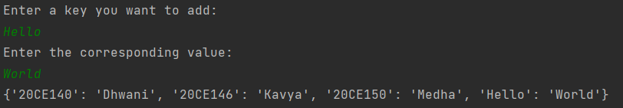  
  
  
#e. Write a Python script to concatenate following dictionaries to create a new one.  
  
#Sample Dictionary :  
#dic1={1:10, 2:20}  
#dic2={3:30, 4:40}  
#dic3={5:50,6:60}  
#Expected Result : {1: 10, 2: 20, 3: 30, 4: 40, 5: 50, 6: 60}  
  
dic1={1:10, 2:20}  
dic2={3:30, 4:40}  
dic3={5:50,6:60}  
dic1.update(dic2)  
dic1.update(dic3)  
print(dic1)

o/p:

  
  
  
###Tuple###  
  
#a. Write a Python program to create a tuple with different data types.  
tp1 = ('item1', 'item2', 'item3',4,5, 1.1);  
print(tp1)

o/p:

  
  
#b. Write a Python program to create a tuple with numbers and print one item.  
tpnum = (1,2,3,4,5,6,7,8,9)  
print('Number at index 1: ',tpnum[1])

o/p:

  
  
#c. Write a Python program to add an item in a tuple.  
tpnum = tpnum + (10,) #This will create a new tuple with original values and 10 at the end  
print(tpnum)

o/p:

  
  
#d. Write a Python program to convert a tuple to a string.  
tp2 = ('d','h','w','a','n','i')  
str = ''  
for item in tp2:  
 str = str + item  
print('String: ',str)

o/p:

  
  
#e. Write a Python program to find the length of a tuple.  
tp3 = ('d','h','w','a','n','i')  
print(len(tp3))

o/p:

  
  
###Set###  
  
#a. Write a Python program to add member(s) in a set and clear a set  
st1 = {1,2,3,4,5,6,7,8}  
st1.add(9)  
print("Set 1: ",st1)  
#clearing the set:  
st1.clear()  
print(st1)

o/p:

  
  
#b. Write a Python program to remove an item from a set if it is present in the set.  
# st1.remove(('item1')) #not present so it won't be removed  
st1 = {1,2,3,4,5,6,7,8,9}  
st1.remove(9)  
print(st1)

o/p:

  
  
  
#c. Write a Python program to create an intersection, Union, difference of sets.  
st1 = {0, 2, 4, 6, 8}  
st2 = {1, 2, 3, 4, 5}  
print("intersection :", st1 & st2)  
print("union: ", st1|st2)  
print("difference :", st1-st2)

o/p:

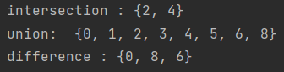  
  
#d. Write a Python program to find maximum and the minimum value in a set.  
st1 = {0, 2, 4, 6, 8}  
print('max: ',max(st1))  
print('min: ', min(st1))

o/p:

  
  
  
#e. Write a Python program to find the most common elements and their counts from list, tuple, dictionary  
#list  
lst = ['first','second','first','third','first','second','second','second']  
count = 0  
element = lst[0]  
for i in lst:  
 ctr = lst.count(i)  
 if(ctr > count):  
 count = ctr  
 element = i  
print(element)

o/p:   
  
#tuple  
tp = ('first','second','first','third','first','second','second','second')  
count = 0  
element = tp[0]  
for i in tp:  
 ctr = tp.count(i)  
 if(ctr > count):  
 count = ctr  
 element = i  
print(element)

o/p:   
  
#dictionary  
dic = {'1':1, '2':2,'3':3,'4':4,'5':2,'1':2}  
tp = tuple(dic.values())  
count = 0  
element = tp[0]  
for i in tp:  
 ctr = tp.count(i)  
 if(ctr > count):  
 count = ctr  
 element = i  
print(element)

o/p: 